LINUX SYSTEM ADMINISTRATION LAB
EX. NO : 1
IDENTIFY THE CURRENT SHELL AND LENGTH OF THE STRING
PROGRAM:
#!/bin/bash
echo "To identify the current Shell and Length of the string"
echo "The Current Shell is = $SHELL"
str1="Welcome to Rathinam College"
echo $str1
len=${#str1}
echo "Length of the string=$len"
OUTPUT:
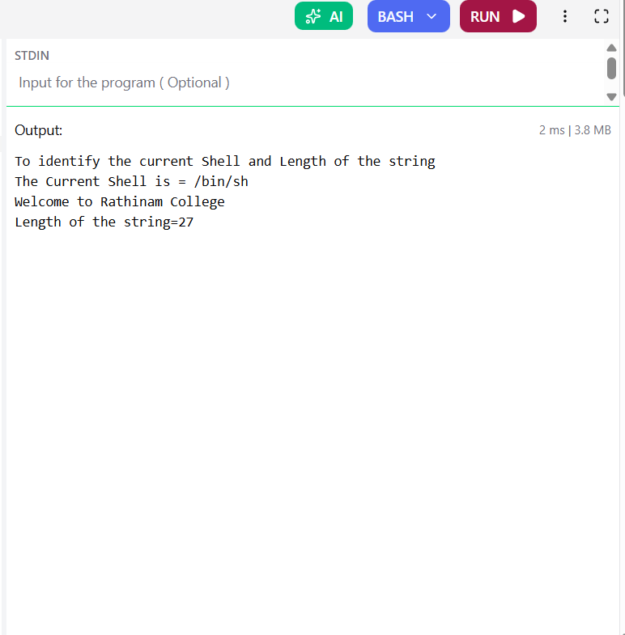

EXNO:2
COUNT BACKWARDS FOR 100 TO 0 USING FOR LOOP
PROGRAM:
#!/bin/bash
echo "To Count backwards for 100 to 0 using for loop"
c=0
for((i=100;i>=0;--i))
do
echo "$i"
s=$[c++]
done
echo"count=$s"
OUTPUT:
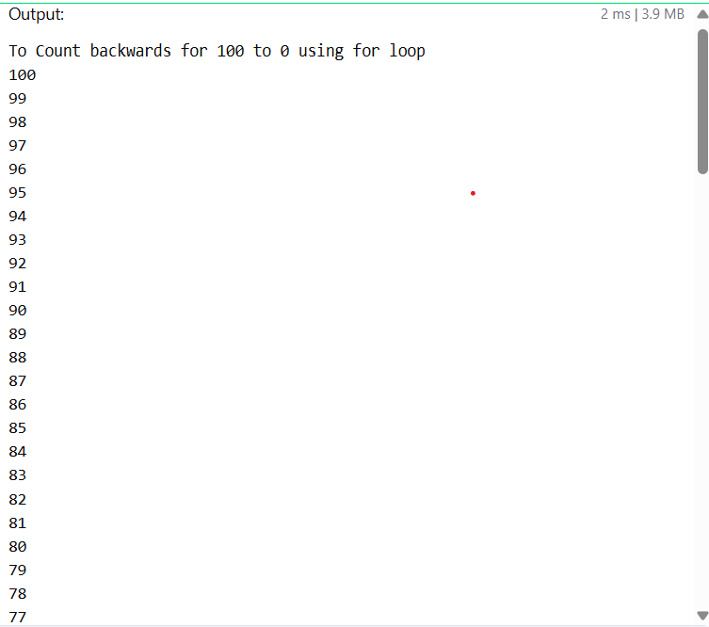
EXNO:3
STAR PATTERN
PROGRAM:
for ((i=5; i>=1; i--))
do
for ((j=1; j<=i; j++))
do
echo -n "*"
done
echo
done
OUTPUT:
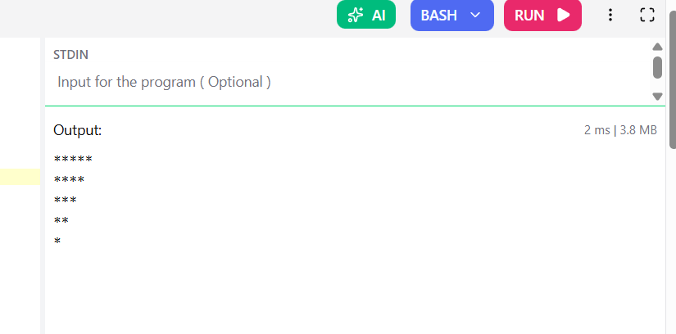

EXNO:4
ODD OR EVEN
PROGRAM:
echo "____________________"
echo "To print even and odd numbers and their count and sums"
echo "____________________"

even_count=0
odd_count=0
even_sum=0
odd_sum=0

echo "Even numbers from 0 to 100:"
for (( i=0; i<=100; i++ ))
do
if (( i % 2 == 0 )); then
echo -n "$i "
((even_count++))
((even_sum+=i))
fi
done

echo -e "\n\nOdd numbers from 0 to 100:"
for (( i=0; i<=100; i++ ))
do
if (( i % 2 != 0 )); then
echo -n "$i "
((odd_count++))
((odd_sum+=i))
fi
done

echo -e "\n\n--------------------------"
echo "Even numbers count = $even_count"
echo "Even numbers sum = $even_sum"
echo "Odd numbers count = $odd_count"
echo "Odd numbers sum = $odd_sum"
OUTPUT:
